Workshop Lecture

Revision Exercises

Exercise 1

1. Write a program to add two numbers and print the result.

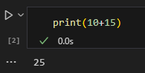

1. Write a program to subtract two numbers and print the result.

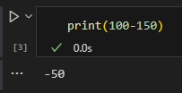

1. Write a program to multiply two numbers and print the result.

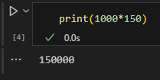

1. Write a program to divide two numbers and print the result.

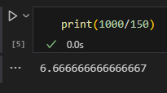

1. Write a program to calculate the remainder of two numbers and print the result.

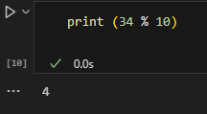

1. Write a program to calculate the power of a number and print the result.

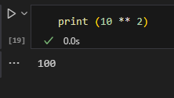

Exercise 2: Python Data Types  
i. Create a list of 5 different fruits and print the list.

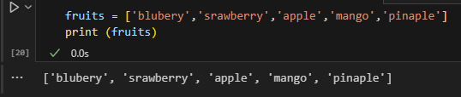  
ii. Create a tuple of 3 different animals and print the tuple.

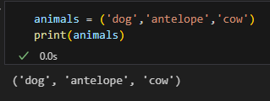  
iii. Create a dictionary of 3 different key-value pairs where the keys are names of  
programming languages and the values are their release dates.

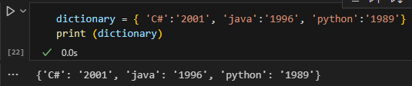  
iv. Create a set of 3 different colours and print the set.

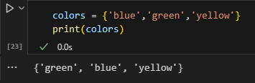  
v. Create a string variable that contains the sentence "Python is an easy-to-learn  
programming language."

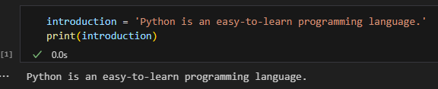

Exercise 3

1. Write a program that takes a user input of a number and checks if it is positive, negative or  
   zero. Print the result.

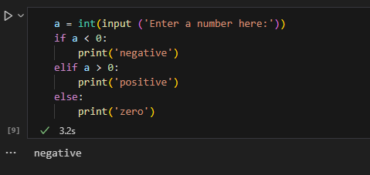

ii. Write a program that takes a user input of a string and checks if it starts with a vowel or  
consonant. Print the result.

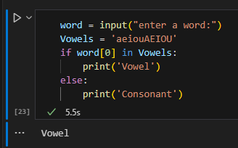

Iii. Write a program that takes a user input of two numbers and checks if they are equal or not. Print the result.

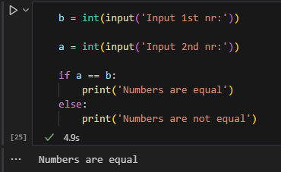

Exercise 4: Loops  
i. Write a program that prints the numbers from 1 to 10 using a for loop.

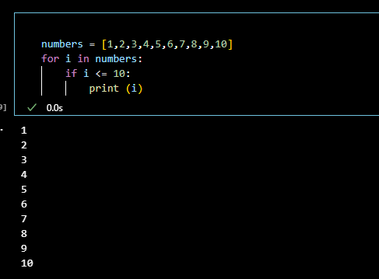  
ii. Write a program that prints the even numbers from 2 to 10 using a for loop.

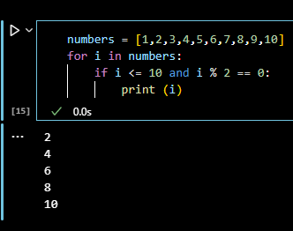

iii. Write a program that prints the first 5 numbers of the Fibonacci sequence using a  
while loop

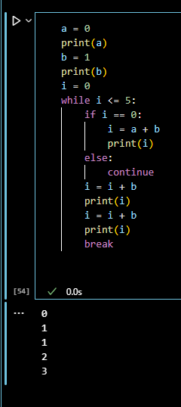

Exercise 5: Functions  
i. Write a function that takes two numbers as parameters and returns their sum.

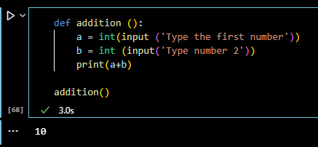  
ii. Write a function that takes a list of numbers as a parameter and returns the largest  
number in the list.

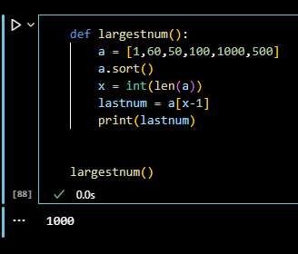

iii. Write a function that takes a string as a parameter and returns the number of vowels  
in the string.

